Name:………………………………………………………Index No……………

553/1
Theory
Paper
Time 2½ Hrs

RESOURCEFUL MOCK EXAMINATIONS 2017
S. 4 BIOLOGY
THEORY PAPER 1
TIME: 2 HOURS 30 MINUTES

Instructions:
Answer all questions in Section A and B, plus any two questions from Section C.
Write answers to section A in boxes along the right hand margin.
Write answers to section A in the spaces provided.
Answers to Section C must be written in the answer booklets provided.

FOR EXAMINER’S USE ONLY
SECTION | MARKS
A
B
C
C
TOTAL

SECTION A

- One major characteristic used to identify class mammalian is
  - Closed Circulatory System
  - Being endothermic
  - Possession of mammary glands
  - An endoskeleton

- Recycling of nutrients in an ecosystem is the function of
  - Producers
  - Customers
  - Detrivores
  - Predators

- A soil with low humus content and coarse particles is most likely to have
  - High capillary
  - High drainage
  - Low aeration
  - High water retention

- Amino acids are to proteins as…………………………………is to starch
  - Maltose
  - Sucrose
  - Galactose
  - Glucose

- When one touches a hot object the hand is removed very fast. The stimulus in this case is the
  - Hand
  - Brain
  - Heat
  - Reflex action

- At high PH the enzyme pepsin may be
  - In activated
  - Denatured
  - Inhibited
  - Destroyed

- When anaerobic respiration occurs we would expect the respiratory quotient to be equal to
  - Infinity
  - One
  - Six
  - Zero

- An organism with full sets of chromosomes is said to be
  - Haploid
  - Diploid
  - Triploid
  - Tetraploid

- Which one of the following responses involves the movement of the whole organism from one place to another?
  - Nastic response
  - Tropisms
  - Reflex action
  - Tactic response

- Dichorgamy is an attempt by plants to adapt for
  - Self pollination
  - Cross pollination
  - Wind pollination
  - Insect pollination

- The initial uptake of water by seeds during germination is carried out by a process called.
  - Osmosis
  - Active transport
  - Diffusion
  - Imbibition

- A fruit with several sutures along which it splits when ripe is called a
  - Berry
  - Legume
  - Capsule
  - Drupe

- One major challenge of animals living on land demands that they
  - Lay eggs
  - Carry out external fertilization
  - Carry out internal fertilization
  - Give birth to living young ones.

- Animal cells placed in a hypotonic may undergo
  - Haemolysis
  - Crenation
  - Plasmolysis
  - Tungidity

- During breathing in man, when diaphragm muscles contract then
  - Thoracic volume increase
  - Thoracic pressure increase
  - Exhalation occurs
  - The diaphragm attains a dome shape

- A hydrostatic skeleton carries out the following functions except:
  - Locomotion
  - Support
  - Movement
  - Production of cells.

- Undifferentiated cells are found in the
  - Parenchyma tissue
  - Xylem tissue
  - Phloem tissue
  - Cambium tissue

- The major limiting factor in photosynthesis at high light intensity is normally
  - Light
  - Water
  - Carbondioxide
  - Chlorophyll

- The target organ for antidiurestic hormone ADH is the
  - Liver
  - Kidney
  - Pituitary
  - Ovary

- Lumbar vertebrae are located in the
  - Thoracic region
  - Back region
  - Abdominal region
  - Neck region

- One major similarity between the respiratory system of insects and man is the presence of
  - A respiratory pigment
  - Cartilage rings
  - A moist surface
  - Network of blood capillaries.

- When a woman of blood group O marries a man of blood AB what is the probability of producing a child of blood group AB?
  - 75%
  - 50%
  - 25%
  - 0%

- Which of the following give a combined affect a high transpiration rate?
    - High atmospheric
    - High humidity
    - High temperature
    - High light intensity
    - High water availability

A. (i) (ii) (iii)
B. (ii) (iii) (iv)
C. (iii) (iv) (v)
D. (i) (ii) (v)

- External digestion of food is a characteristic of
  - Amoeba
  - Paramecium
  - Houseflies
  - Mucor

- Which one of the following would make an analogue pair of organs?
  - Wings of birds and wings of insects
  - Wings of bats and wings of birds
  - Fore limbs of man and fore limbs of dogs
  - Tail in an monkey and caudal fin of fish

- The major nutrient obtained by carnivorous plants by this behaviuor is
  - Manganese
  - Nitrates
  - Iron
  - Magnesium

- Both urine formation and tissue fluid formation involve
  - Ultra filtration
  - Selective reabsorption
  - Active transport
  - Osmosis

- Which of these events occurs together when focusing on a distant object by the human eye?
    - Contraction of circular iris muscles
    - Contraction of radial iris muscles
    - Contraction of circular ciliary muscles
    - Contraction of radial ciliary muscles
    - Suspensory ligaments slacken
    - Lens becomes thin
    - Lens becomes thick

A. (i) (iii) (v) (vii)
B. (ii) (iv) (vi) (viii)
C. (iv) (vi) (vii)
D. (iii) (v) (vi)

- Diabetes mellitus is as a result of malfunction of the
  - Pituitary
  - Pancreas
  - Liver
  - Kidney

- Panting in dogs is aimed at
  - Cooling the body
  - Paying the oxygen debt
  - Getting rid of excess carbondioxide
  - Obtaining maximu m oxygen

SECTION B
- In an investigation, two persons A and B drank the same amount of a glucose solution. Their blood sugar levels were determined immediately and thereafter at intervals of one hour for the next six hours. The results were as shown in the following table.
 | Blood glucose level (mg/100ml)
Time (hours) | Person A | Person B
0 | 90 | 120
 | 220 | 360
 | 160 | 370
 | 100 | 380
 | 90 | 240
 | 90 | 200
 | 90 | 160

- Use same axes to present the information in the table graphically.

- Give reasons(s) for each of the following observations.
- Blood sugar level increased in person A between O and 1 hour

………………………………………………………………………………………………………………………………………………………………………………………………………………………………………………………………………………………………
- The blood sugar level decreased in person A between 1 and 4 hours

………………………………………………………………………………………………………………………………………………………………………………………………………………………………………………………………………………………………
- From the graph, what is the normal blood sugar level for human being?

……………………………………………………………………………………………………………………………………………………………………………..………………
- Suggest a reason for the high sugar level in person B.

………………………………………………………………………………………………………………………………………………………………………………………………
- How can the high blood sugar level in person B be controlled?

………………………………………………………………………………………………………………………………………………………………………………………………
- What is the biological significance of maintaining a relatively constant sugar level in the human body?

…………………………………………………………………………………………………………………………………………………………………………………………..…
- Give reason for the decrease in the blood sugar level of person B after 4 hours.
………………………………………………………………………………………………………………………………………………………………………………………………………………………………………………………………………………………………

- The diagram below shows the structure of a nephrone

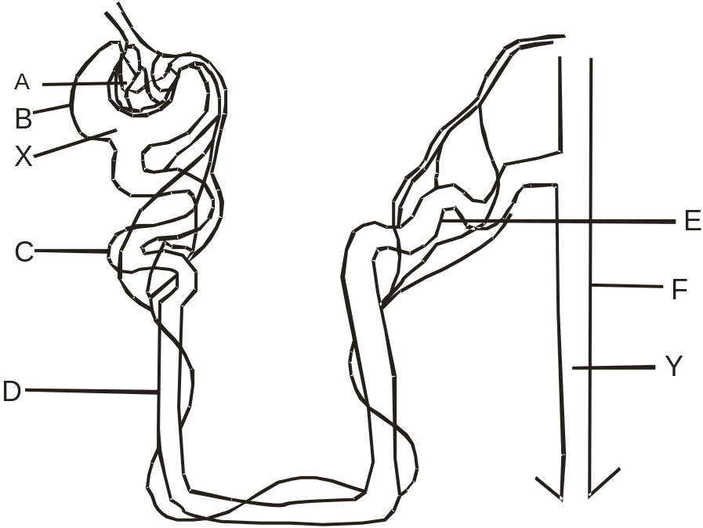

- Name the parts labeled;

A: …………………………………. D………………………………..
B: …………………………………. E………………………………..
C: …………………………………. F………………………………..

- (i) What name is given to substances x and y?

X: ………………………………………………………………………………..
Y: ………………………………………………………………………………..
(ii) State the composition of the substance x and y

Substance | Composition

- Which factors affect the composition of substance Y?

…………………………………………………………………………………
…………………………………………………………………………………
…………………………………………………………………………………
…………………………………………………………………………………

- A students set up an experiment as shown below;
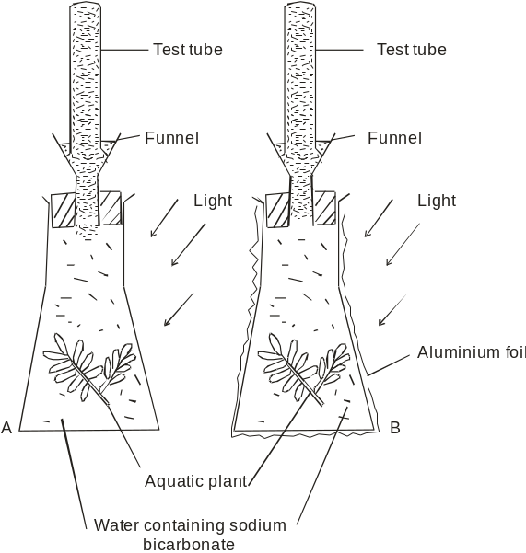

- State the aim of the experiment

…………………………………………………………………………………
…………………………………………………………………………………
- State what would be observed in the experiment after two hours.

i) Observations in A

…………………………………………………………………………………
…………………………………………………………………………………
…………………………………………………………………………………
ii) Observation in B

…………………………………………………………………………………
…………………………………………………………………………………
…………………………………………………………………………………
- State the reason for using the following;

i) Water containing sodium bicarbonate

…………………………………………………………………………………
…………………………………………………………………………………
…………………………………………………………………………………
ii) Aluminium foil

…………………………………………………………………………………
…………………………………………………………………………………
…………………………………………………………………………………
- State two other factors which could affect this experiment.

i) ………………………………………………………………………………
ii)………………………………………………………………………………
- Which other test needs to be carried out before making a conclusion for this experiment?

…………………………………………………………………………………
…………………………………………………………………………………
…………………………………………………………………………………
…………………………………………………………………………………
…………………………………………………………………………………

SECTION C
Answer any two questions

- a) What is pollution?
b) Describe man’s activities which lead to water pollution
c) Explain how water pollution affects wild life.

- a) Explain why sometimes seeds fail to germinate even when provided with the necessary
conditions.

b) State the conditions necessary for germination.
c) Describe an experiment to show that oxygen is necessary for germination to occur .

- a) Describe the adjustments which occur in a human aye.
i) In very dim light
ii) In very bright light.
b) Explain why the image of an object may fail to be focused on to the retina of a human eye.
c) Explain how the problem in (b) above can be corrected.

- During a Medelian experiment, a cross between pea plants with round and wrinkled seeds produced F₁ with round seeds only.
- Explain the absence wrinkled seed in the F₁
- Using suitable symbols, work out the F₂ genotypes and phenotypes.
- Explain how you would determine the genotype of an F₂ plant bearing round seeds.

---- END ---

